SMALL EXPERIMENTS

NAME: K.SUSHRUTH
REG NO: 192411073
COURSE CODE: CSA4311 IP

- Profile page

<!DOCTYPE html>
<html>
<head>
<title>My Profile</title>
</head>
<body>
<h1>My Profile</h1>
<p><b>Name:</b> K. Sushruth</p>
<p><b>College:</b> Saveetha</p>
<p><b>Department:</b> Computer Science</p>
<p><b>Email:</b> student@gmail.com</p>
<h3>About Me</h3>
<p>I am a college student interested in programming.</p>
</body>
</html>

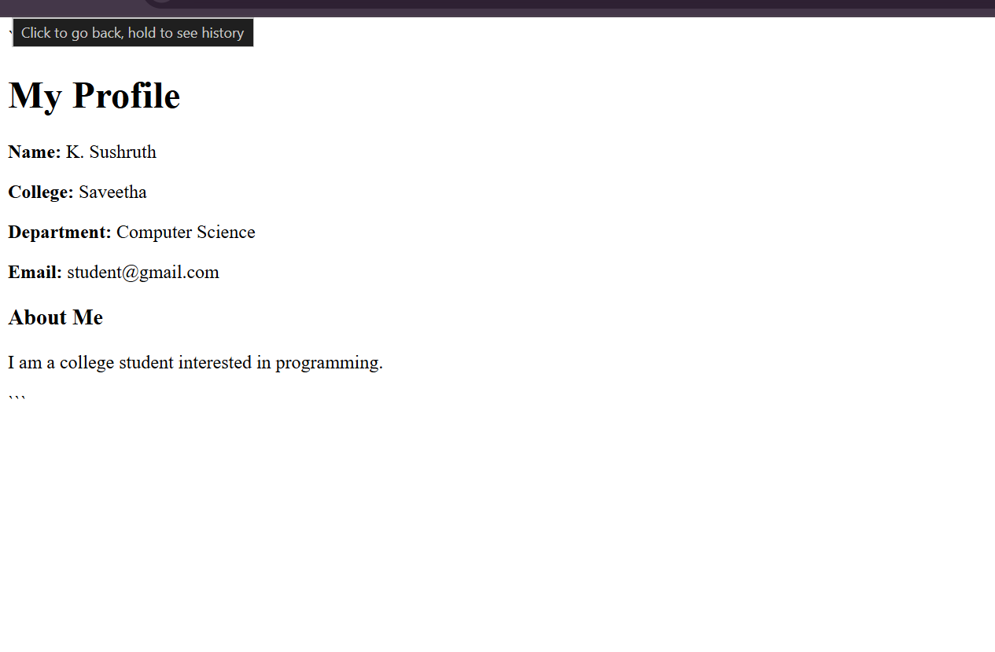
- Create table to store 3 subjects


- CO MARKS
<html>
<body>
<h2>Student Marks</h2>

<form>
Name: <input type="text" id="name"><br><br>
CO1: <input type="number" id="c1"><br><br>
CO2: <input type="number" id="c2"><br><br>
CO3: <input type="number" id="c3"><br><br>

<button type="button" onclick="save()">Save</button>
</form>

<p id="result"></p>

<script>
function save() {
document.getElementById("result").innerHTML =
document.getElementById("name").value + "<br>" +
"CO1: " + document.getElementById("c1").value + "<br>" +
"CO2: " + document.getElementById("c2").value + "<br>" +
"CO3: " + document.getElementById("c3").value;
}
</script>
</body>
</html>

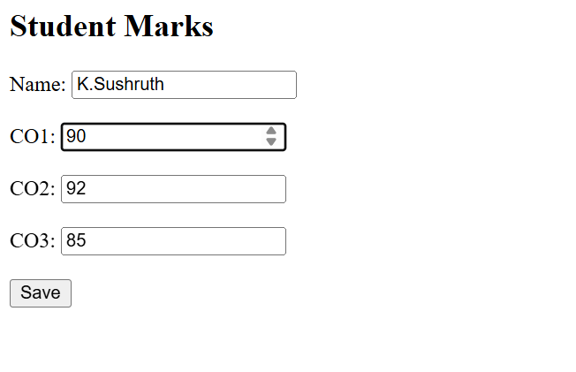
- COLLEGE IMAGE

<html>
<body>
<h2>My College</h2>
<img src="college.jpg" width="300" height="200">
</body>
</html>


- Simple arthemetic calculator

<html>
<body>
<h2>Simple Calculator</h2>

<input type="number" id="a" placeholder="First number"><br><br>
<input type="number" id="b" placeholder="Second number"><br><br>

<button onclick="calc('+')">+</button>
<button onclick="calc('-')">-</button>
<button onclick="calc('*')">*</button>
<button onclick="calc('/')">/</button>

<p id="result">Result:</p>

<script>
function calc(op) {
let a = Number(document.getElementById("a").value);
let b = Number(document.getElementById("b").value);
let r;

if (op == '+') r = a + b;
else if (op == '-') r = a - b;
else if (op == '*') r = a * b;
else if (op == '/') r = b != 0 ? a / b : "Cannot divide by zero";

document.getElementById("result").innerHTML = "Result: " + r;
}
</script>
</body>
</html>

